**DAILY ONLINE ACTIVITIES SUMMARY**

|  |  |  |  |  |  |  |  |
| --- | --- | --- | --- | --- | --- | --- | --- |
| **Date:** | **15-06-2020** | | | | **Name:** | **Jaidithya** | |
| **Sem & Sec** | **6 B** | | | | **USN:** | **4AL17CS118** | |
| Online Test Summary | | | | | | | |
| **Subject** | | **Workshop python test** | | | | | |
| **Max. Marks** | | **20** | | **Score** | | **17** | |
| Certification Course Summary | | | | | | | |
| **Course** | **One java program and C programming and Python workshop class** | | | | | | |
| **Certificate Provider** | | | **-** | **Duration** | | | **5 DAYS** |
| Coding Challenges | | | | | | | |
| **Problem Statement-executed programs in google colab.** | | | | | | | |
| **Status:Executed** | | | | | | | |
| **Uploaded the report in Github** | | | | **Yes** | | | |
| **If yes Repository name** | | | | **Day1** | | | |
| **Uploaded the report in slack** | | | | **Yes** | | | |

Online Test Details: (Attach the snapshot and briefly write the report for the same)

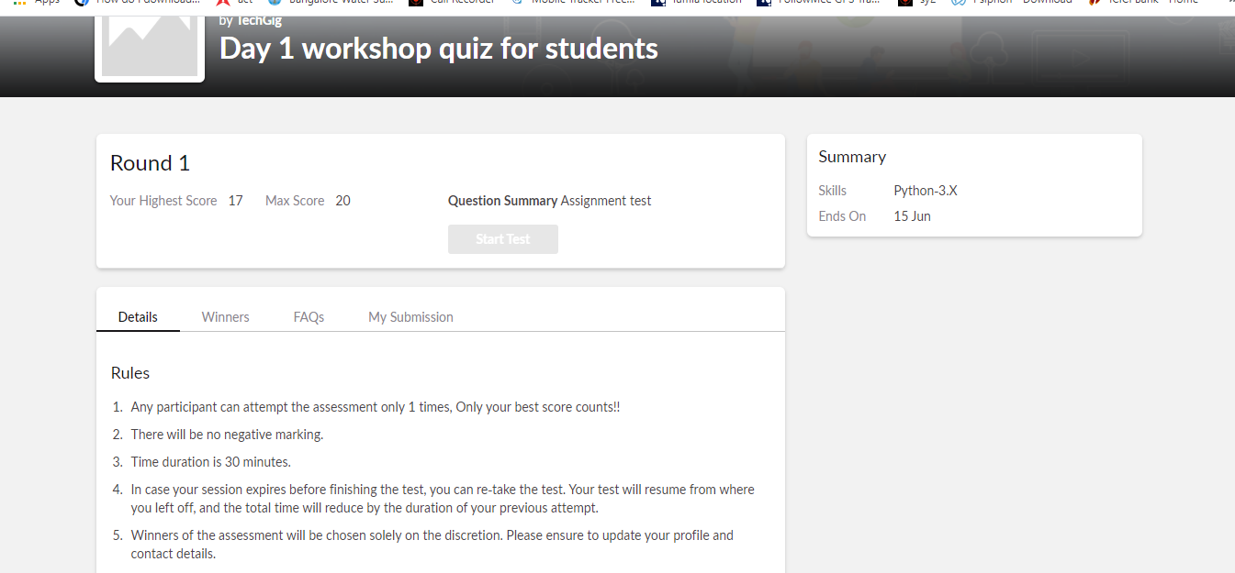

Certification Course Details: (Attach the snapshot and briefly write the report for the same)

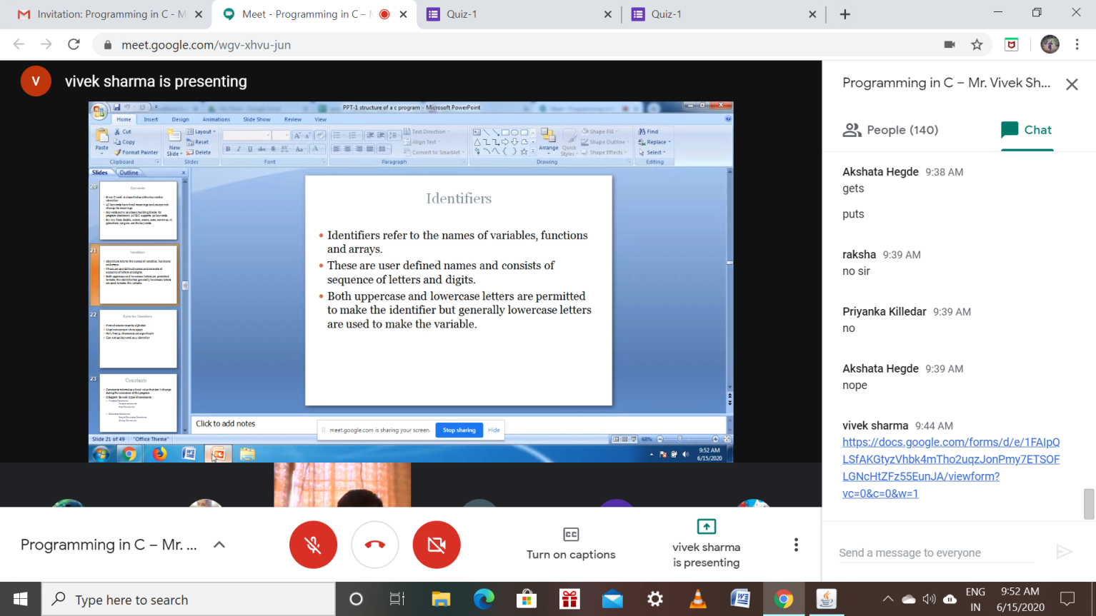

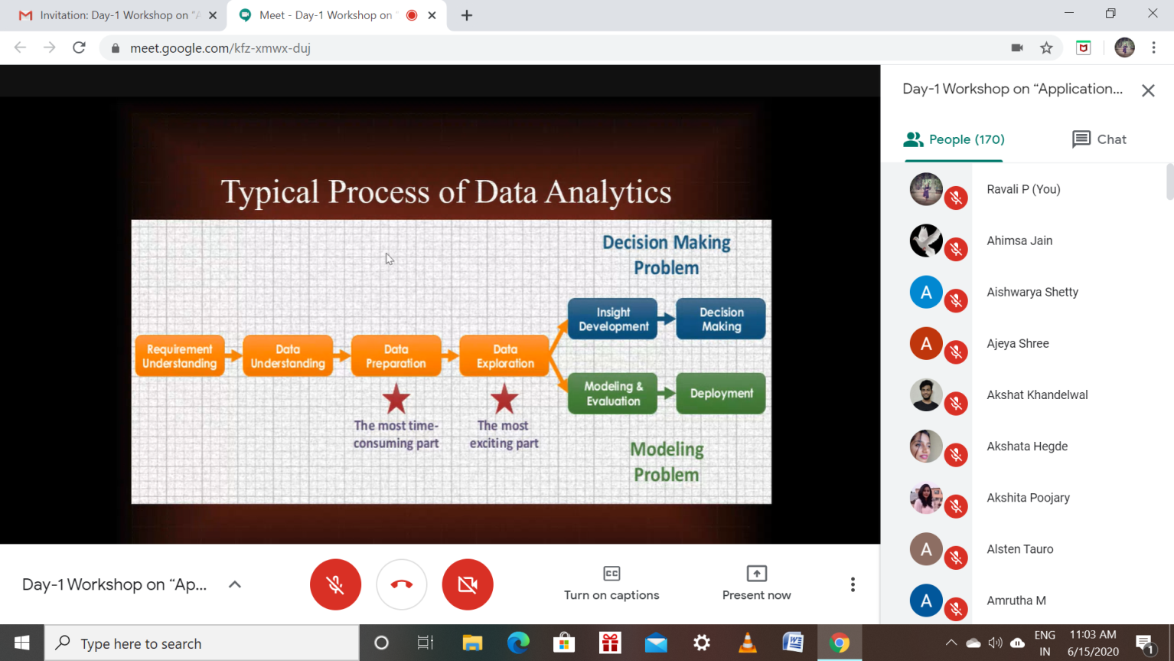

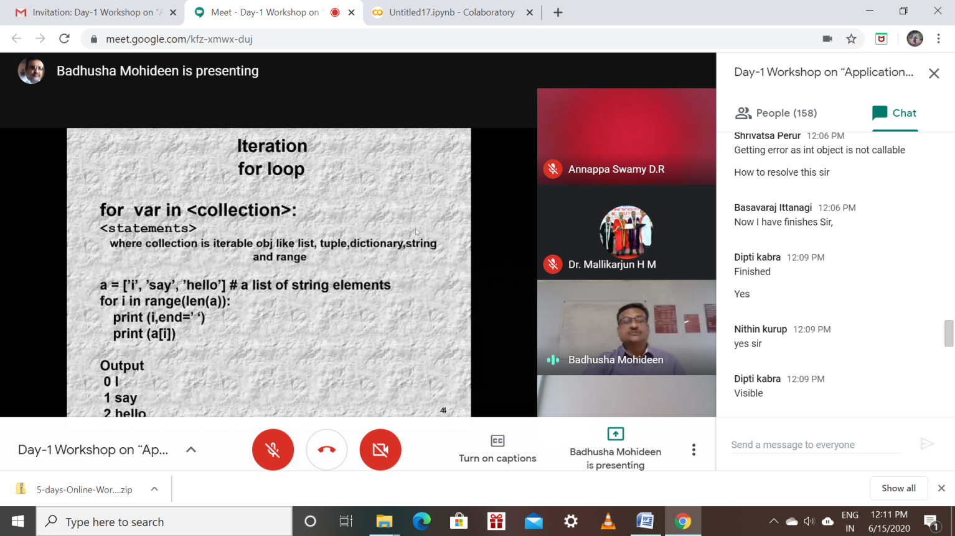

Coding Challenges Details: (Attach the snapshot and briefly write the report for the same)

Program1:

